Assignment - 4

|  |  |
| --- | --- |
| **Student Name/ID Number:** | Agung Yuda Pratama/BDSE07-0922-076 |
| **Academic Year:** | 2022 |
| **Module Name:** | Front End Web Development |
| **Project Title:** | Single Page Application |
| **Submission Date:** | 12-10-2022 |

12-10-2022

Date:

Student signature:

I certify that the work submitted for this assignment is my own and research sources are fully acknowledged.

**Learner declaration**

|  |
| --- |
| **Purpose of this project** |
| **Purpose of this project**  To demonstrate your capabilities in the following areas:   * Plan a Website & Develop branding, wireframes, information architecture & storyboard. * Develop a website using HTML, CSS & JavaScript. * Develop jQuery Menus & Tabs * Develop a Single Page Application * Execute the test cases and validate the website meets the design requirements. * Configure the virtual host and deploy the application |
| **Submission Format** |
| 1. Website screenshot in word document 2. Source code |
| **Project Brief & Guidance** |
| **Scenario:**  Setup the Application (Download the source code) in Apache and get the screen capture of Modify the application to add a product detail page for each product (4 pages, 1 page for each product)   1. Change the product price based on the currency selected. 2. Create your own json file for currency conversion 3. Call a Server-Side Script with product Id. 4. Read the product page using the Server-Side Script. 5. Display it in the main content area of the demo products page. 6. Configure Apache to use Single IP Address (your local IP Address) to host [www.](http://www/)<studentno>-1.com   [www.](http://www/)<studentno>-2.com  Define the document root as below C:/vhosts/<studentno>-1 C:/vhosts/<studentno>-2   1. Secure the host [www.](http://www/)<studentno>-2.com using .htaccess and .htpassword 2. Deploy the application and capture the screenshot as below |

|  |
| --- |
| The website that you have developed needs to be tested by you and final sign-off should be  taken from ‘ABC Learning Center’ (Mentor) before hosting it on their web server. |
|  |

**HOMEPAGE**

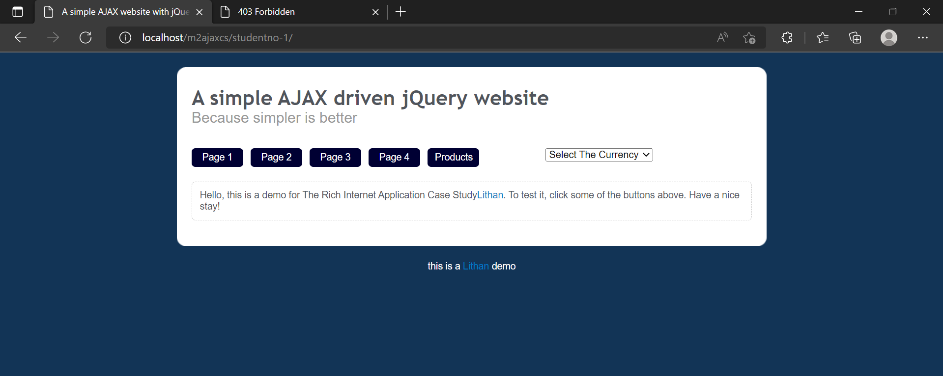

**PAGE 1**

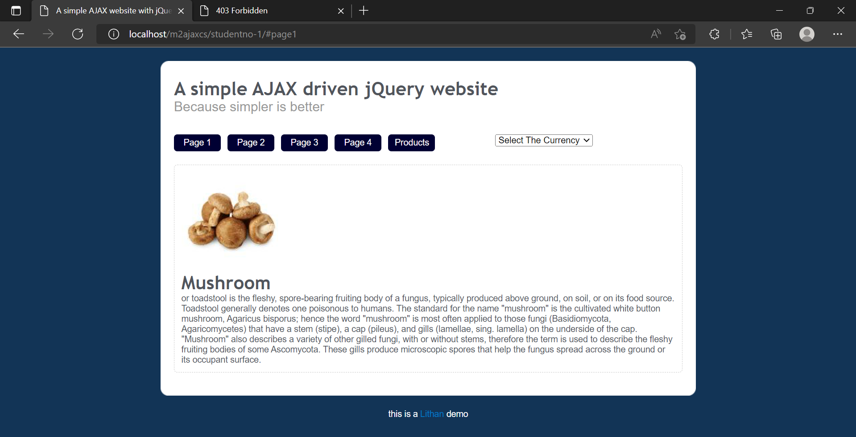

**PAGE 2**

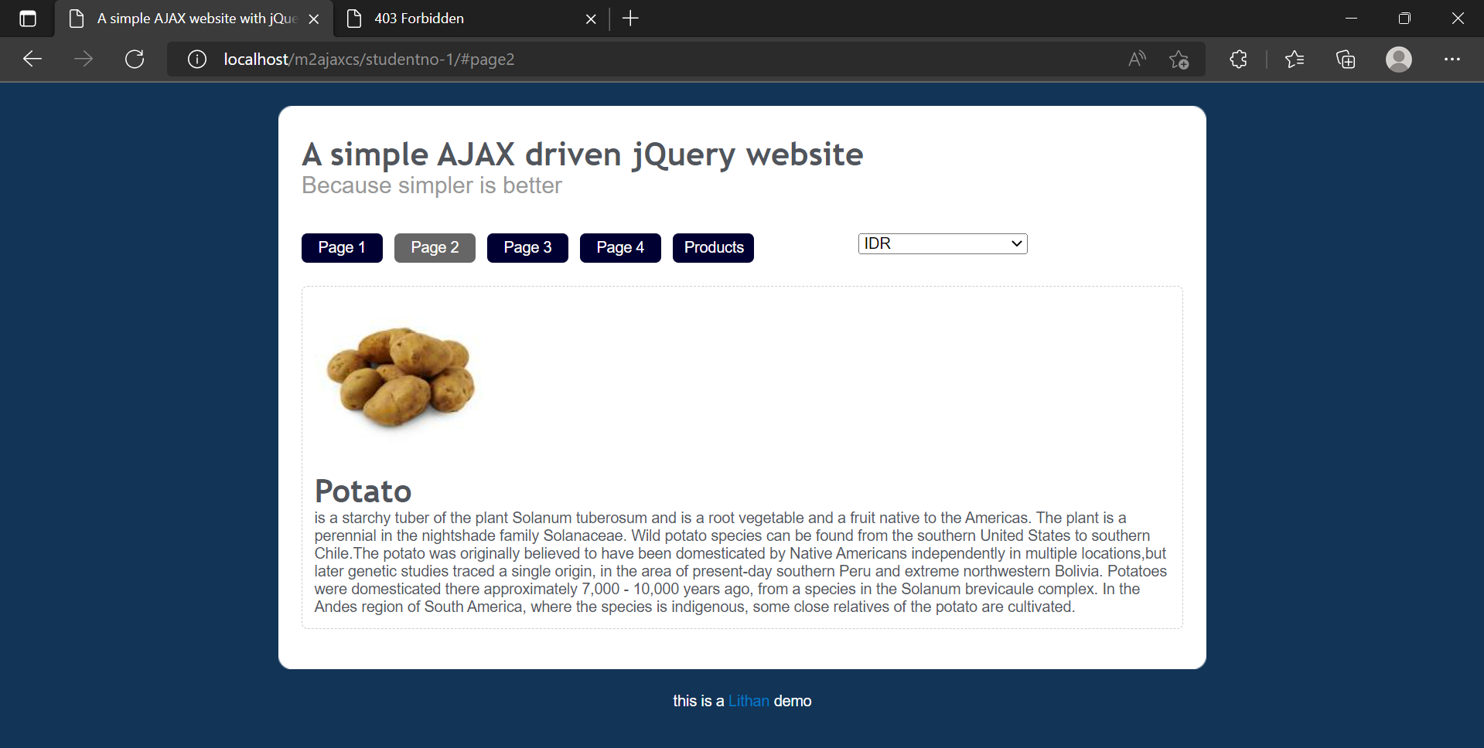

**PAGE 3**

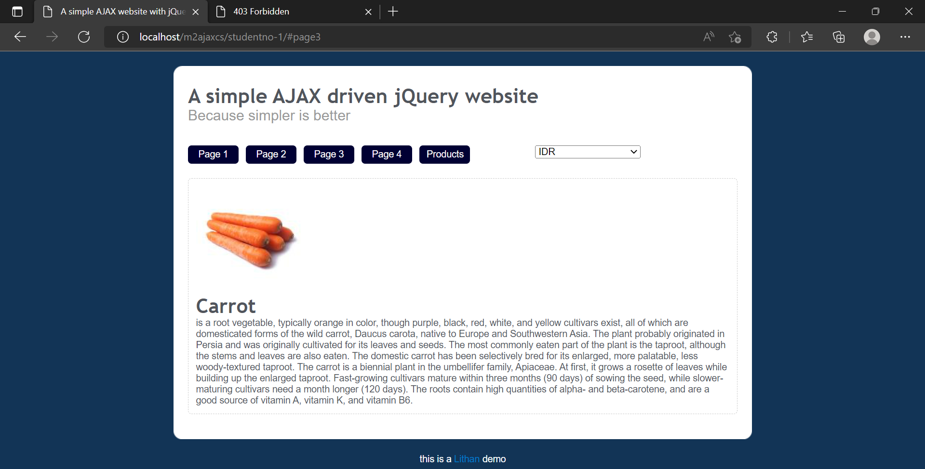

**PAGE 4**

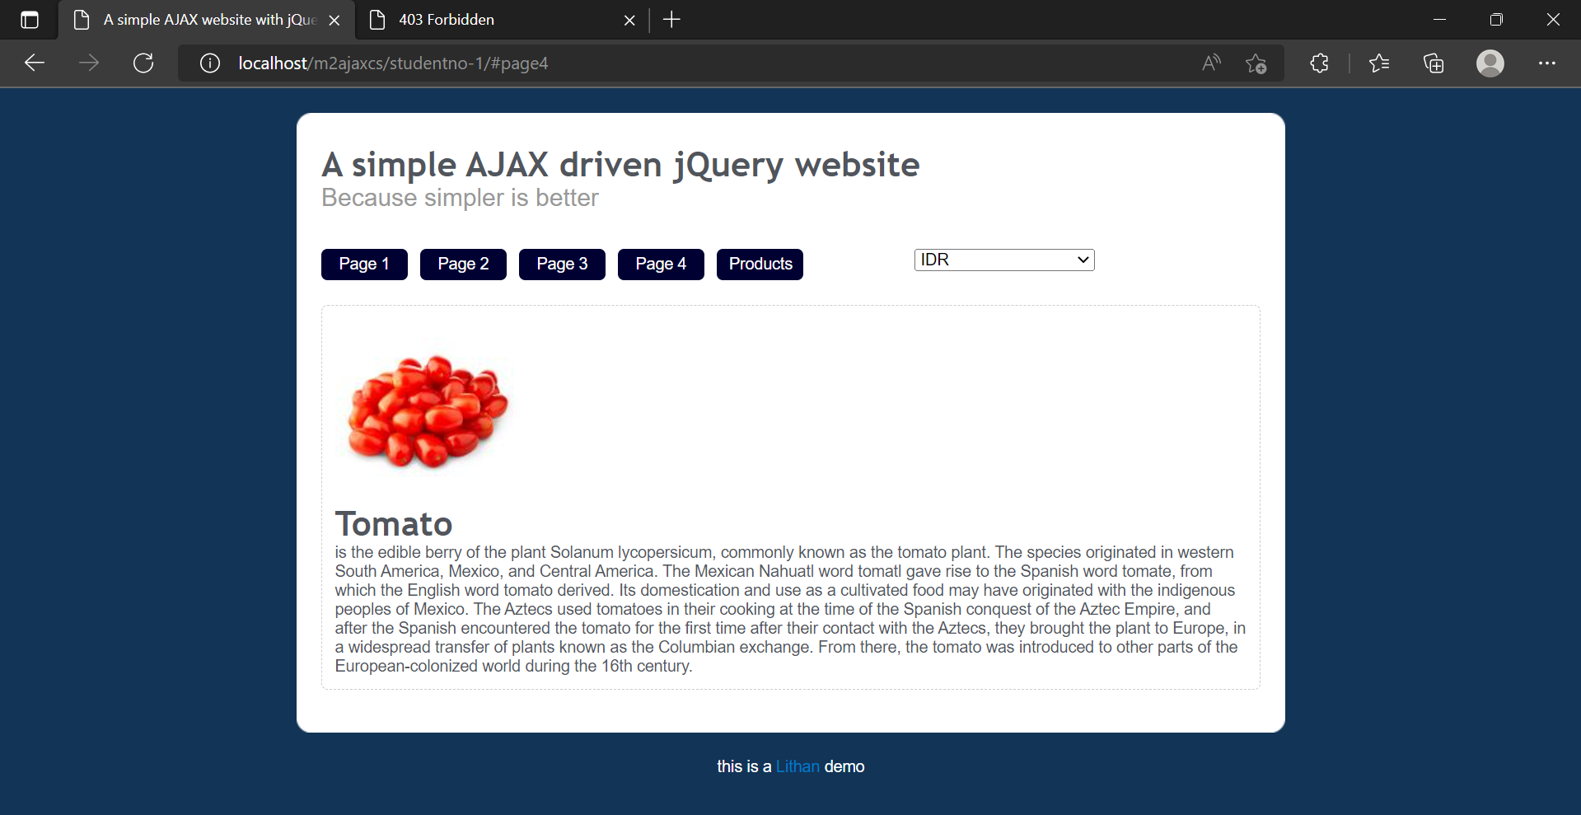

**PAGE PRODUCT**

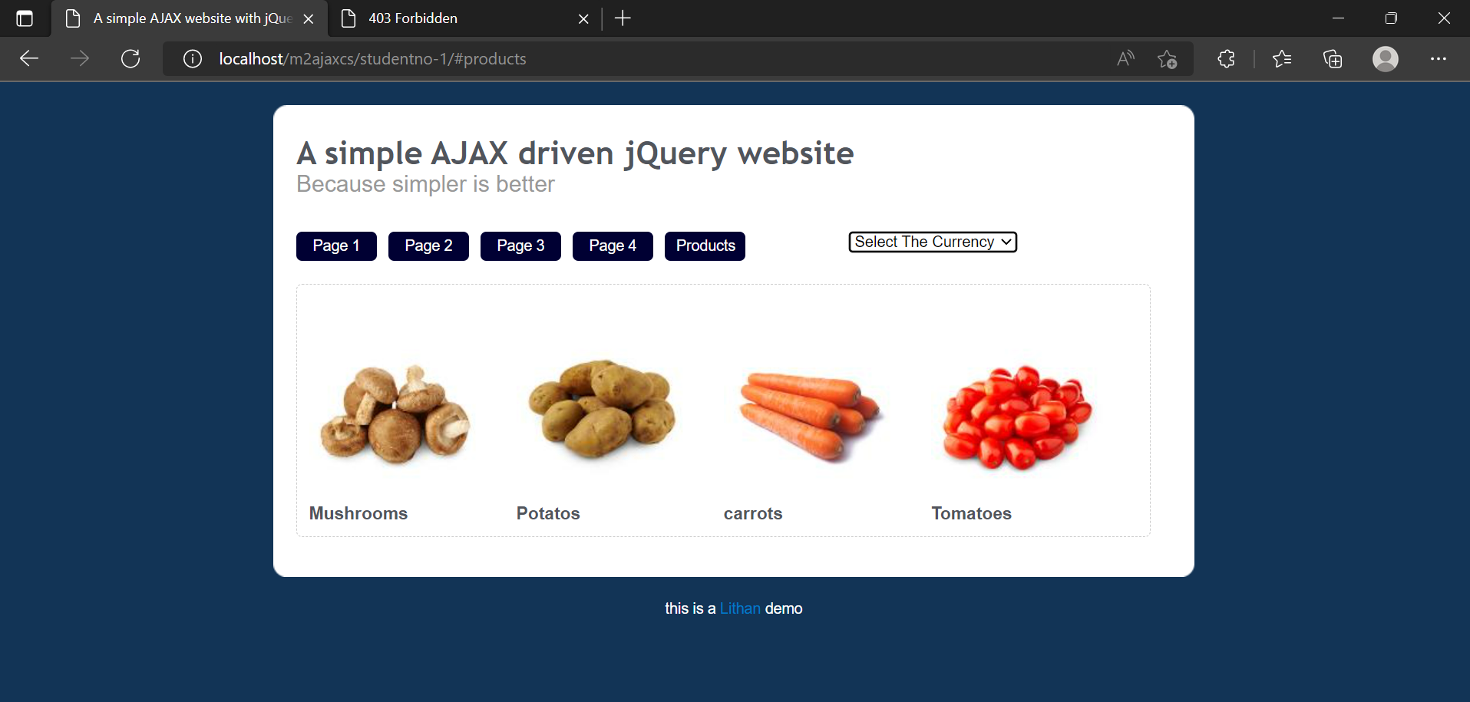

**IDR CURRENCY**

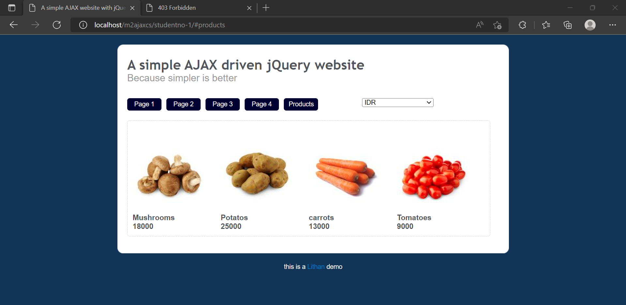

**SGD CURRENCY**

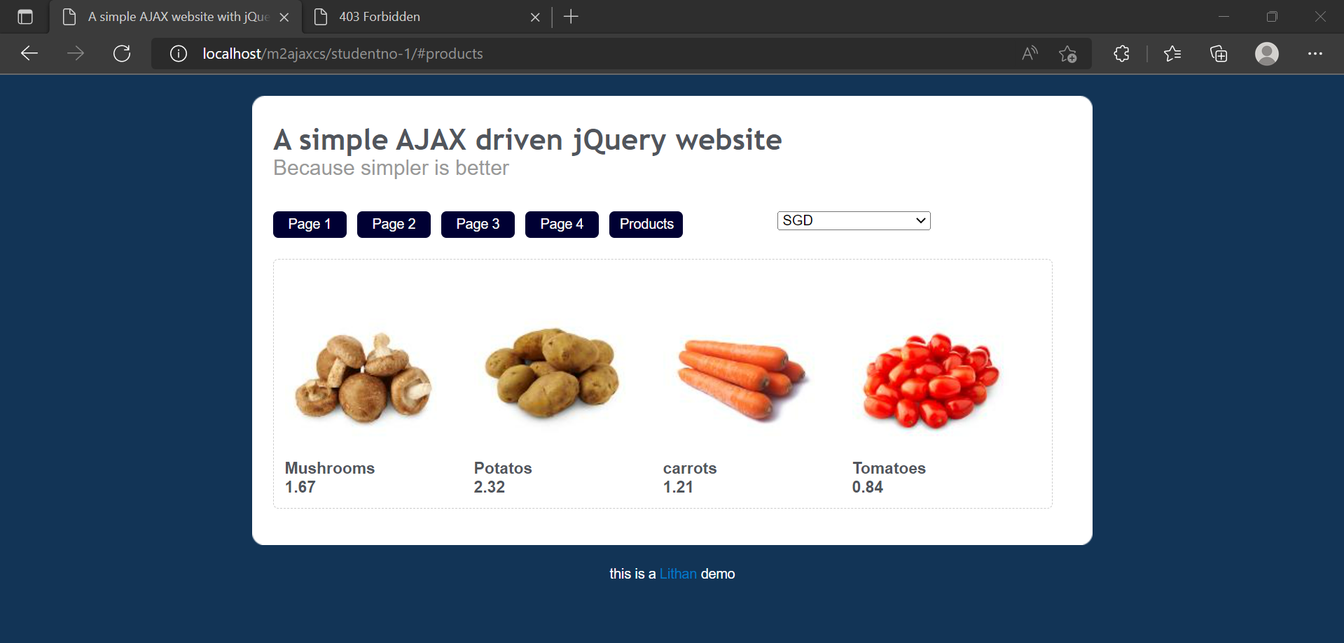

**YEN CURRENCY**

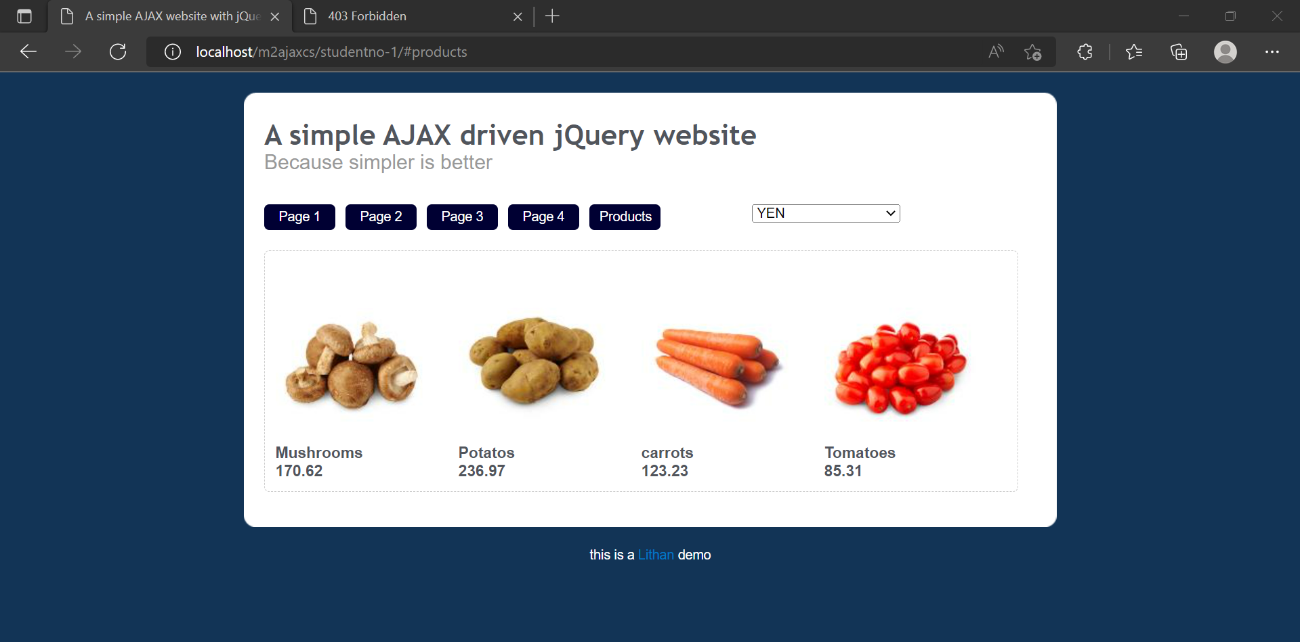

**STUDENT NO 2**

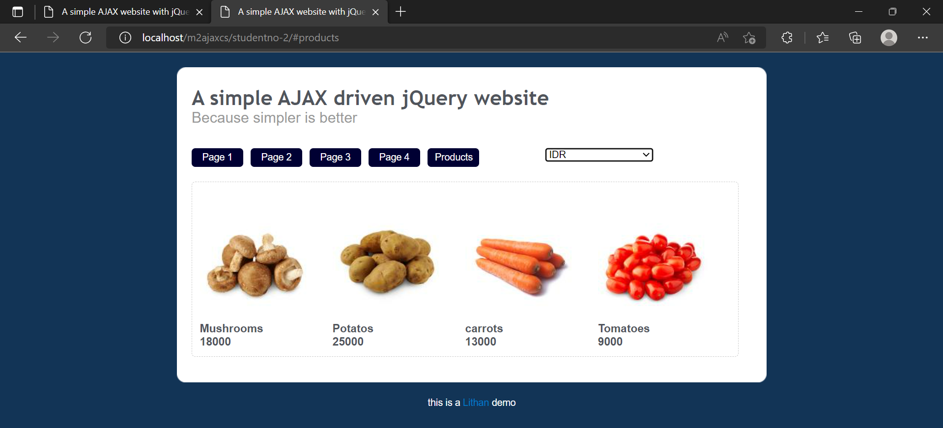

**STUDENTNO-2/IMG (.htaccess for IMG is forbidden)**

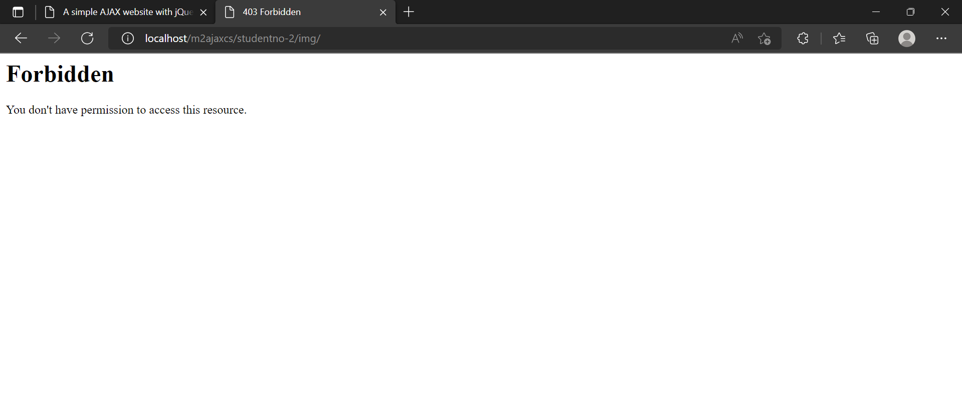

**APACHE FOLDER**

